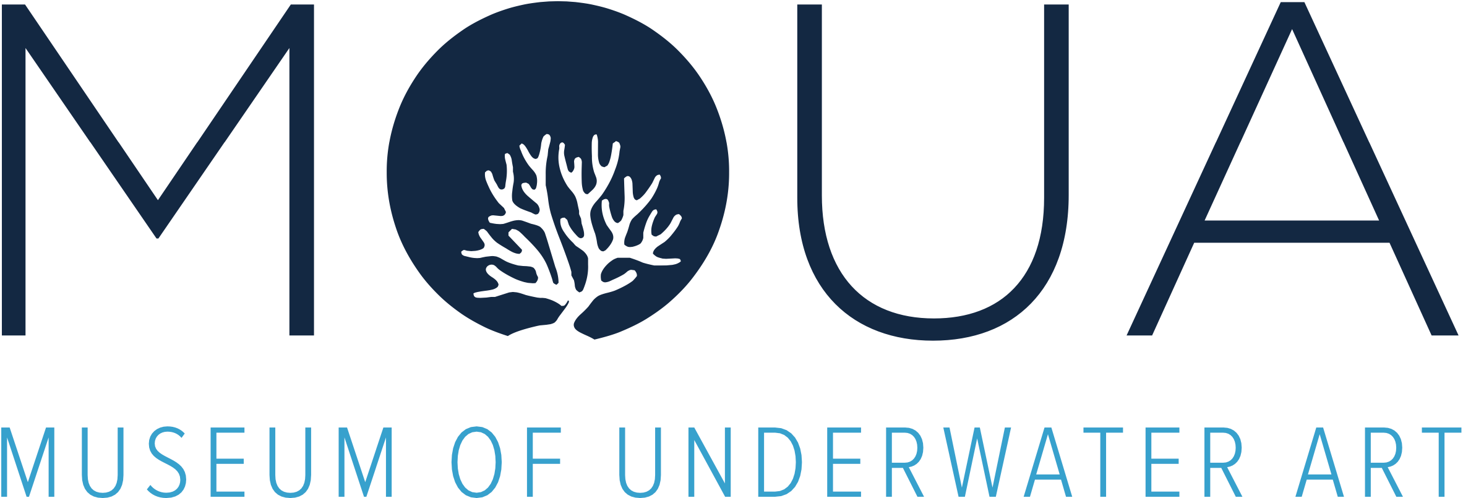

#LoveTheReef #SmallChanges Checklist

WHAT CAN I DO?
Each and every one of us can contribute to fighting climate change and protecting the Great Barrier Reef by making simple everyday changes.

MAKE SMALL DAILY CHANGES
By taking collective action, we can effectively combat climate change and ensure the long-term health of the Great Barrier Reef - all it takes are some simple changes to our daily routine.

ACTIONS YOU CAN TAKE AT HOME
ACTIONS YOU CAN TAKE AT WORK
ACTIONS YOU CAN TAKE AT SCHOOL
ACTIONS YOU CAN TAKE ON THE REEF

ACTIONS YOU CAN TAKE AT HOME
Reduce electricity use
- Turn off power at the wall when not in use
- Use energy efficient appliances and LED light fittings
- Catch the breeze with open windows instead of air conditioners
Reduce your carbon emissions when getting around
- Ride, walk, carpool or use public transport
- Consider vehicles with improved fuel efficiency
- Look at ways to reduce your greenhouse gas emissions
Consider using renewable energy
- Install solar power and solar hot water systems
- Purchase green power if available
Reduce, reuse or recycle
- Donate items to charity or swap with friends and family, don’t send to landfill
- Recycle whatever and whenever you can
- Look for food and products with minimal or no packaging, or packaging that can be recycled
- Audit how much plastic you’re using and find ways to minimise it, for example take reusable containers for your lunch, reusable shopping bags, or purchase bulk foods
Stop using single-use
- Bring your own reusable coffee cups and say no to single-use straws
- When eating out, take reusable containers and cutlery instead of using plastic

Be a conscious consumer
- Make informed choices about the products you buy and, where possible, consider choosing sustainable and ethical products
- Swap and share products, buy second hand, and buy locally-produced items
Literally make changes in your house and backyard
- Set up a worm farm and use the castings to fertilise your garden
- Compost food scraps, shredded paper, grass clippings, leaves and cuttings (except noxious weeds and diseased cuttings), vacuum cleaner dust, used vegetable oil, tea leaves and bags, coffee grounds and egg shells
- Wash your car on the lawn to minimise detergent runoff into drains
- Operate your dishwasher and washing machine only when you have a full load
- Minimise water runoff by planting trees, garden beds and ground cover around your home
- Use environmentally-friendly cleaners and fertilisers
- Keep gutters, sinks and drains free of chemicals and rubbish — what washes down sinks and drains could end up on the Reef
- Clean filters in your air conditioner and dishwasher regularly so they run efficiently
Get involved
- Join community clean-ups
- Share your messages and knowledge about the Reef with others

ACTIONS YOU CAN TAKE AT WORK
Reduce and recycle
- Encourage recycling at your workplace
- Only order the stationery you need
- Think before you print and utilise electronic publishing
- Re-use office paper — use recycled paper and promote double sided printing and copying
- Take your own coffee mug instead of using polystyrene cups
- When organising events, avoid single-use plastics and look for food and products with minimal or no packaging, or packaging that can be recycled
Reduce energy consumption
- Switch off lights when not in your workplace
- Turn your computer monitor off when not in use
- Have your air conditioner maintained regularly

ACTIONS YOU CAN TAKE AT SCHOOL
At home action to take to school
- Pack a ‘nude food’ zero waste lunchbox
- Use bento box style lunchboxes to pack food without plastic wraps or packets
- Use reusable water bottles, not single-use plastic
Get involved in school activities and education initiatives
- Encourage recycling and revegetation program
- Reduce plastic use in your school and conduct a waste audit to target the most common items
- Conserve and manage water and energy use in school buildings
- Hold a clean-up day at your school, park, creek, beach or oval
- Form an environmental committee in your school to make your school more sustainable
- Join the Great Barrier Reef Marine Park Authority Reef Guardian Schools program (if your school is in the catchment region)
- Use the 'at home' messages at your school — get everyone involved

ACTIONS YOU CAN TAKE ON THE REEF
Protect your patch — follow zoning rules out on the water, report illegal activity, and follow these responsible reef practices
- Take your rubbish home with you
- If you see rubbish, pick it up and recycle or dispose of it thoughtfully
- Choose high standard tourism operators with eco certification
- Take part in Eye on the Reef, a monitoring program that enables anyone who visits the Great Barrier Reef to contribute to its long-term protection Simply download the app and share what you see or complete a monitoring survey
- Check out Responsible Reef Practices tips before heading out on the water

